Ladies.. lets lift!

**FITNESS TIPS WITH BREEDON PRIORY HEALTH CLUB**

Bone building

**Lots of women feel intimidated by the misconception that picking up a weight or going heavier on the leg press will bring about ‘bulky’ biceps or ‘titanic’ thighs. However! Strength training is more beneficial towards sculpting and toning that desired leaner body. Here are 7 reasons as to why women should be challenging those weights**!

As ladies, we are more prone to Osteoporosis (low bone mass) at a later age. However, we can decrease that risk by **strengthening our bones**. Lifting weights has proven to increase bone density thus preventing the development of fragile bones and fractures.

Reduce Risk of Injury

Burn, Baby, Burn

You may find yourself cringing over the idea of lifting heavier weights due to fear of injury. However, according to reseach, sports such as football, Olympic weightlifting and many more, are seen as a lot more dangerous. Yet, that does not mean you should be throwing weights around the room as soon as you start- **injuries still happen.** Lifting weights is great at reducing injury due to maintaining connective tissue and joint strength. However, always be **smart and safe** when taking part in any activity. If you are unsure of how to use equipment ask a qualified trainer or ask your gym to book an **induction** of the equipment for you.

Muscle is metabolically active. Thus, building more muscle from strength training creates a **higher basal metabolic rate**, meaning more calories are being burnt even at rest! In fact, strength training is shown to be even **more effective** at fat loss than cardio alone. In 2 months, with strength training 2-3 times a week, as well as cardiovascular (**concurrent training**) you can gain 2 pounds of muscle **BUT** lose 3.5 pounds of fat! Each pound of muscle is equivalent to burning 35-50 calories more a day! **AMAZING!!**

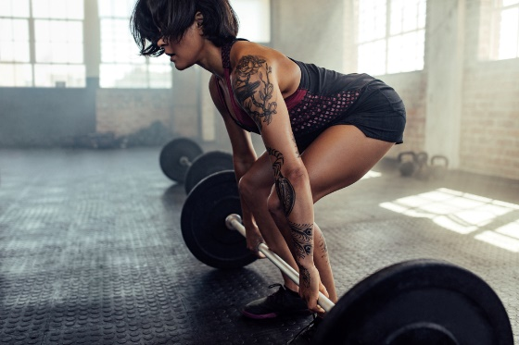

Perfect Posture

The best part of my weight lifting journey, as well as seeing the results, was the idea of perfecting my posture and my form when performing my strength exercises. **Quality over quantity** is an important quote to focus on when lifting weights- **Don’t go heavy!** Having great form brings about an improvement within your posture. Lifting weights the right way strengthens your back, shoulders and core and also reduces back pain.

As we get older our fast- twitch muscles, which aid us with our speed and power movements as well as our balancing mechanisms, start to deteriorate. **But not to worry-** resistance training activates these muscles fibres more efficiently. Thus strength training increases our balance due to building up the muscle fibres to contract quicker. This means we are able catch ourselves better when we lose balance.

Balance boost

**Concurrent training** (strength and endurance) also benefits massively when it comes down to enhancing your overall mood. The release of endorphins from lifting those weights, **if done correctly**, will gradually reduce stress, anxiety, sleep problems and help fight off depression. In addition, your heart and brain will thank you! Weight training in the long-run will also help with the functioning of your vital organs, as well as developing your self-confidence and esteem- **making you feel great**!

Be a happier, healthier you

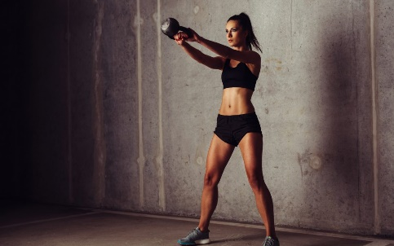

If you don’t want to look super ‘Bulky’, weight lifting is still an option. With concurrent training women simply don’t have enough testosterone to create ‘bulging’ muscles. Women have 10-30 times less testosterone than men. So stepping into the weights section won’t turn you into the ‘incredible hulk’ but into a more muscle defined toned **wonder woman**.

Strength not size