Hypertrophy Arm workout
- Focus: To add muscle size and strength to the biceps and triceps:
- Warm up: Lat pull down machine
- 20 reps light weight to get the blood flowing to the arms and upper body.
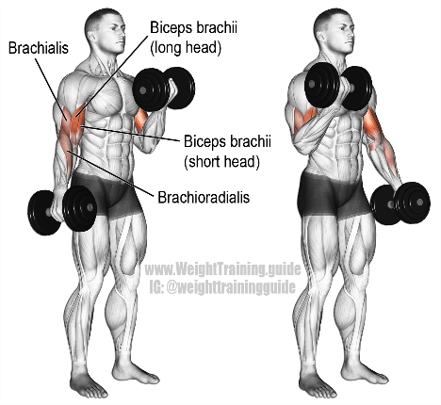
Exercise 1: Dumbbell Bicep curls
Sets: 3 Reps: 10

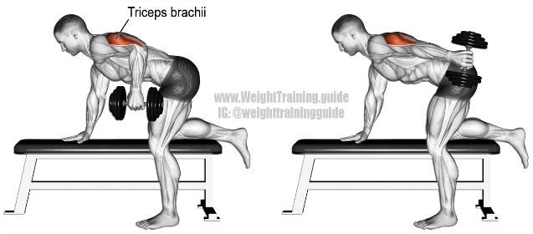
Exercise 2: Dumbbell tricep Kickback / Overhead DB tricep press super set
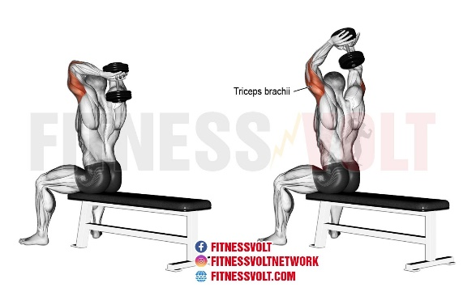
Sets: 3 Reps: 10 per exercise

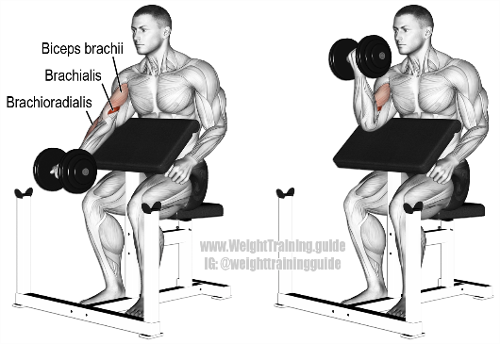
Exercise 3: Dumbbell preacher curl (set the bench to 45 degrees).
Sets: 3 Reps: 10

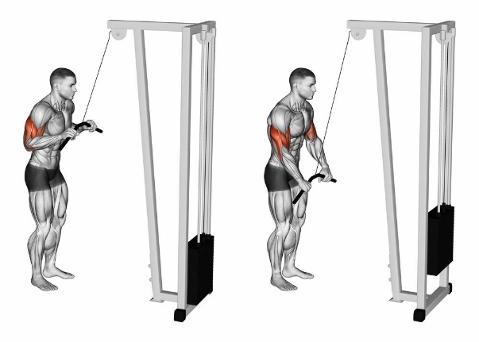
Exercise 4: Cable tricep pushdown (rope attachment)
Sets: 3 Reps:10

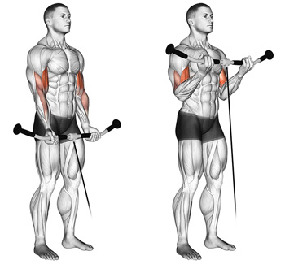
Exercise 5: Cable Bicep curl (bar attachment).
Sets: 2 x Triple drop sets (10 reps, then reduce the weight by 25%, 10 reps reduce by 25% again, finish with 10 more reps).

