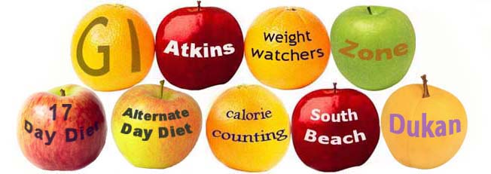
How to Find the Best Diet for You
They’ve been part of our lives for as long as we can remember, and the origins can be traced back to Ancient Greece where ‘diaita’ represented an entire way of life; food, lifestyle and exercise. Apart from other practises of running naked and regular vomiting, they had a point!
At that time, the ideal body was male and for women who aspired to this needed to get creative with diaita. Now the dieting industry doesn’t discriminate and there are countless choices for everyone!
The new year brings a commitment to losing weight and be healthier, cue a minefield of 100’s of different companies telling you theirs is the best. It can be so overwhelming that we may not even get started or we’ll try several in the hope that one of them will stick (this year!)
Here’s my top tips of what to look for when choosing a weight loss plan:
Be Suspicious! Anyone who claims they have the definitive, guaranteed solution to weight loss is talking rubbish; we are all individuals and therefore we will respond differently to changes. It is accepted we look different on the outside, but some have allergies, are left handed, tolerate different foods. There’s no ‘one size/fits all’ to be healthy.
Adherence. You need to like the food you eat, punishing yourself with a cabbage diet if you hate greens won’t see you past 12th night! Similarly, you need to end the program knowing what to eat in a sustainable way for life or the weight will just return. Yo-yo eating will cause havoc with the digestive system, making weight loss harder to achieve.
Nutritional Balance. Unless medically advised or if you have ethical preferences, it’s not necessary to exclude any food to achieve health weight loss. This leads to nutrient imbalance and send cravings through the roof!
Health Focus. What is the measure of success of the diet? A program that measures by purely aesthetic may help you to get into a dress or suit that fitted you 5 years ago but will it provide you with the strength and energy to play with your children/grandchildren or however you want to spend your time?

For more information on how to find a healthy, personalised approach to losing weight & eating well get in touch for an informal chat!

