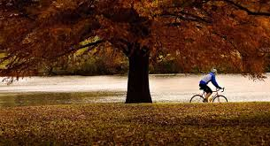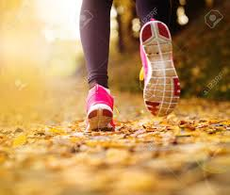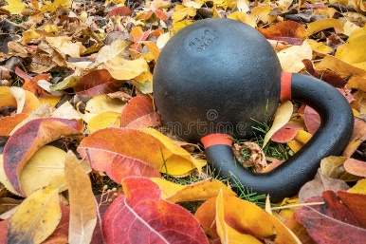**FITNESS TIPS WITH BREEDON PRIORY HEALTH CLUB**

**Take advantage of autumn**

Create good habits for the holiday season by taking advantage of that autumn weather. Fall can be a delight for the senses, so stimulate them by exercising in the great outdoors! Discover some trails around your area and try going for a walk, a bike ride or even a hike. Enjoy those cooler temperatures!

When you are dragging yourself to the gym on a cold Monday morning or evening, it is so easy to talk yourself out of it. Yet, finding a friend to meet you there and cheer you on will make you less likely to quit. Having that workout buddy will allow you to enjoy your workout more and push yourself harder during those “miserable” months.

**Fitness friend**

Keeping on track with that routine from summer all the way through to autumn and winter is a big yes! Having regular exercise will make you feel more energetic- making it easier to rise and shine during those earlier hours. Staying active during autumn has even been suggested to strengthen the immune system, improve your mental well-being and additionally give you a greater sense of self-esteem. So keep active!

**Keep it regular**

**Don’t curl up and hibernate!**

**All the gear? Great idea!**

This is not essential, but can provide you a massive boost when wanting to feel motivated during those cooler days. According to some studies, wearing certain clothes influences our behaviour and attitude. So wearing a new brightly coloured sport top, in turn, could make you feel more “fun” and “happy”. Feeling better about yourself therefore, may cause you to perform better and be more active. So dress to impress!

As the weather changes, staying inside where it is cosy with a hot chocolate seems excessively tempting. However, during the colder months exercising daily is a lot more important. Around autumn time, people tend to put more weight on due to moving a lot less and over indulging in comfort foods. So make sure you keep moving! Get out the house! Even if it is for a brisk walk or a quick visit to the gym for a workout or a class.

Whether you are someone who is crazy about cardio or wild about weightlifting, repeating the same routine, especially going into the winter months, can become tedious. Make sure you keep your routine fresh! If you do the same class every week, try something new! Try swapping your yoga for a spin class! Why don’t you go a different route on your morning jog? Have a crack at researching some different and unique exercises to fit in to your programme. Mix it up!

**Rejuvenate your routine!**

Throughout the year, summer is seen as the best time to be active. With the sunlight staying around for a lot longer, it seems that getting up earlier and squeezing in a morning gym session is a lot easier. However, eventually autumn creeps around the corner bringing along with it those shorter, darker and colder days. Some people may find it difficult to get up and out during these frosty months. Yet, unbelievably, autumn is actually the perfect time to start focusing on your fitness. Here are some top tips on how to stay motivated during those chilly days.

Fall into Fitness