Diabetes & Exercise

According to Diabetes UK “12.3 million people in the UK are at risk of developing Type 2 diabetes.” Around 7.0% of men and 4.9% of women are living with some form of diabetes in the UK - of which 85%-90% are type 2 diabetics.
Type 1 diabetes cannot be prevented around 8% of people in the UK have this type, where your body attacks pancreas cells that create insulin, insulin injections are therefore needed to lower blood glucose levels. Symptoms include; excess thirst, frequent urination, weight loss.
Type 2 diabetes is where insulin your pancreas creates can’t work properly, or where insufficient insulin amounts are produced, often caused by overuse. Insulin is needed to allow for diffusion of glucose (broken down from food such as carbohydrates) into the body’s cells for to be used for energy. Without insulin blood glucose levels cannot be regulated which can cause secondary issues such as kidney damage, blood vessel damage, loss of eyesight and even lead to amputations of limbs. This form of diabetes is often caused by lifestyle factors such as eating sugary foods that are quickly absorbed into the blood (high GI), inactivity or abdominal obesity that all increase your risk of developing type 2 diabetes. Symptoms include increased thirst, frequent urination, blurred vision, weight loss, fatigue, headaches. However around 60% of cases are asymptomatic (Diabetes UK). However around 3/5 cases of Type 2 diabetes can be prevented or delayed by improving lifestyle factors.
How can we manage type 2 Diabetes?

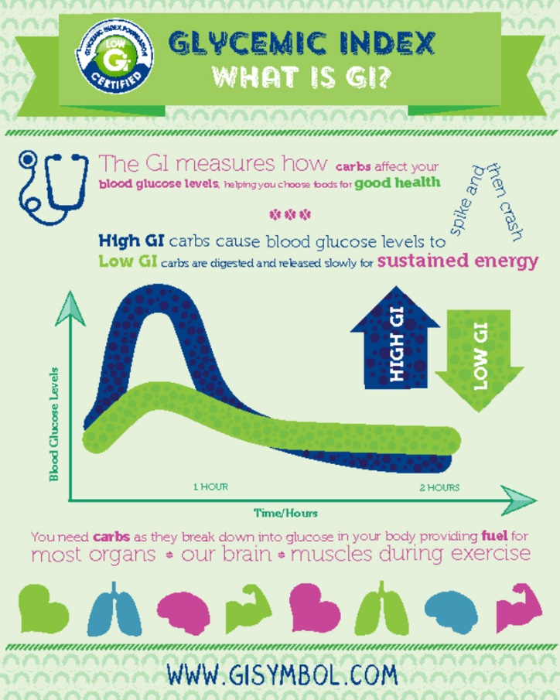
Type 2 diabetes can be regulated by medication such as metformin to reduce liver glucose production and help regulate blood glucose levels. As well as this surgical intervention such as gastric band surgery could put someone into remission, one key factor in developing type 2 diabetes is being overweight therefore losing weight can reverse the issue. However, improving lifestyle factors such as eating well and increasing activity levels can help reduce your risk or help manage/ reverse symptoms of type 2 diabetes – and should be the first port of call.

Nutrition:
- Focus on eating healthy balanced meals. The key is to cut down on high GI (glycaemic index) carbohydrates (such as white breads, rice, sweets, chocolate, potatoes) this increases your risk of developing type 2 diabetes - this is due to how rapidly high GI foods cause blood glucose to spike and therefore the demands on the pancreas for insulin is high.
- Lower processed food intake.
- Stay in energy balance to control weight (calories in = calories out) as high body fat % increase the risk of developing type 2 diabetes significantly.
- Opt for Low GI foods that take longer to break down (oatmeal, wholegrain bread, barley, sweet potato etc).
- Include a moderate intake of unprocessed meat, fish and whole food starches, as well as a variety of fruit and veg per day.

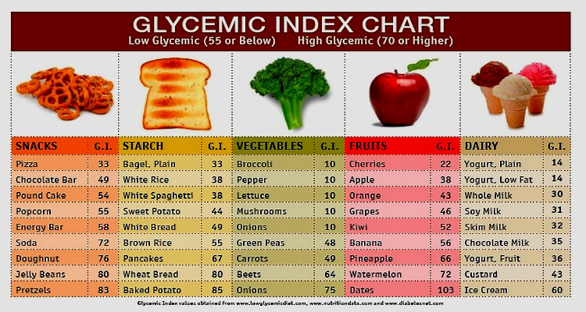
See Below some food examples with their GI score:
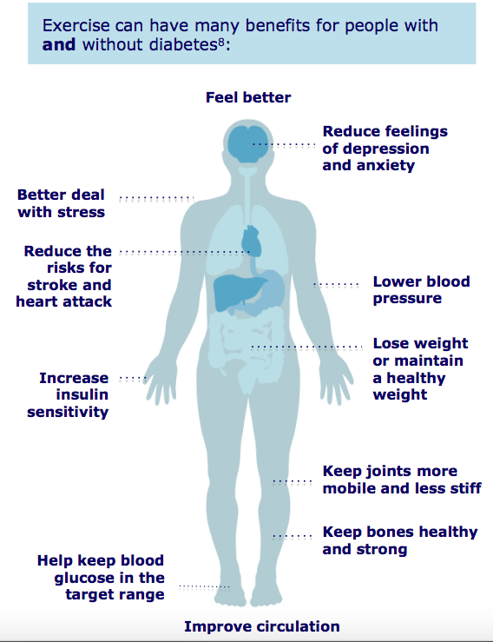
Exercise: Exercise can also help prevent your risk of developing type 2 diabetes by helping you lose weight or maintain a healthy weight – high body fat % increases your risk.
Muscle contraction during exercise also stimulates blood glucose uptake to provide muscle with energy in to exercise, causing blood glucose levels to fall. This therefore takes stress off the pancreas and also reduces the reliance on medications - exercise is a natural way of lowering blood glucose levels.
Exercise can also help improve sleep; inadequate sleep can often cause binges on simple carbohydrates the following day to provide “pick me ups:” when feeling fatigued, this can then cause the pancreas to overwork to regulate blood glucose and can increase the risk of developing type 2 diabetes. Better sleep quality = reduced risk.

So how much and what exercise should I be doing?
- You should aim to get 30 minutes of moderate cardiovascular activity 5 days a week such as walking quickly, cycling, swimming gently (150 mins per week).
- Or 15 minutes of vigorous exercise 5 times a week, this is where breathing rate is taken up to cause difficulty talking, such as running, cycling fast, fast swimming.
- You should try to get a combination of aerobic (walking, jogging, swimming, cycling) and resistance exercises into your programme. With 2 weighted sessions per week ideally (such as squats, lunges, bicep curls, shoulder presses). Following the guide of 1-3 sets, 10-15 reps of each exercise at 40-50% of maximum effort.

So get active, join your local gym, go for a walk or even ride a bike; limit high GI sugary food sources and try to maintain a healthy balanced diet and you’ll lower your risks of developing type 2 diabetes or even manage/reverse your symptoms.

For more information on managing diabetes or reducing your risk of developing diabetes contact Kirsty one of our personal trainers.

