Who’s Got Your Back?

Healthy shoulder blades are a rarity in our society. The problem is the amount of time we spend sitting in front of computers, steering wheels and on our phones. The hunched position we tend to assume in these situations can lead to a more severe condition called kyphosis which can be a more or less permanent forward rounding of the upper spine.
This posture inhibits the ability of the scapula (shoulder blade) to tilt backward and create space for the rotator cuff (the group of muscles and tendons) in the shoulder joint when the arm is lifted overhead. As a result, the rotator cuff gets pinched.
The impact of our lifestyle habits mentioned above means our shoulders are internally rotated and pushed forward for long periods of time. This leads to laxity and weakness in the muscles that externally rotate and retract the shoulders.
Eventually, these imbalances cause the shoulder blades to float away from the spine toward the shoulder sockets, known as scapular winging. A healthy shoulder blade is sucked up tight against the ribcage. If your shoulder blades are visibly poking out of your upper back when you stand with your arms at your sides, then you have scapular winging.

There are several exercises that can help you become aware of this area and your posture. Strengthening and stretching should be something that you build into your routine on a regular basis without taking too much time.

Try these for starters and get in touch with what’s going on behind you!

Shoulder Band Flyes
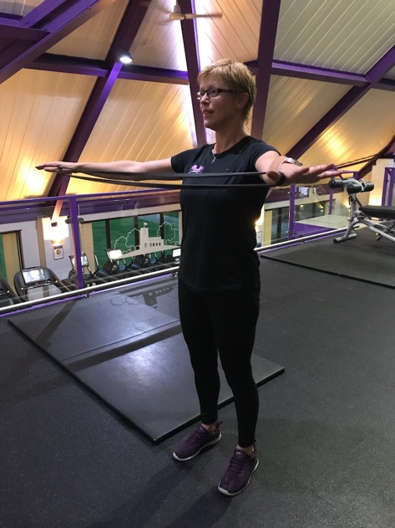
Hold a resistance band in both hands with your hands about shoulder-width apart and your palms facing the ground.

Stand tall and press your chest out as you raise your arms up straight in front of you at about shoulder height. Keep your neck and shoulders relaxed and do not shrug.

Then keeping your arms straight and up at about shoulder height, pull out on the band to open your arms out to the sides as you bring the band in toward your chest.

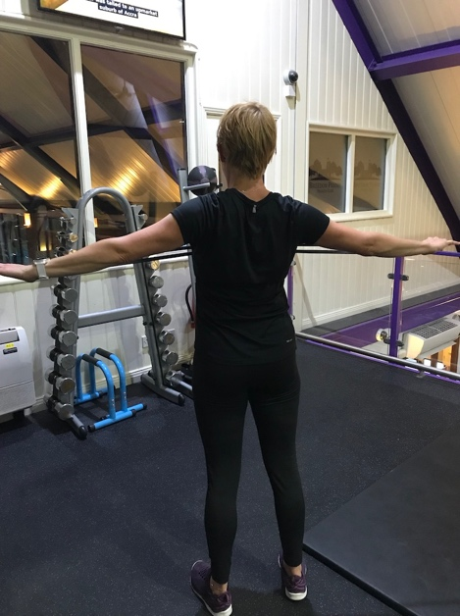
Pinch your shoulder blades down and together as you fly your arms open and stretch the band. Do not let your shoulders shrug up or bend your arm as you pull the band.

Feel your back working and your shoulder blades drawing together.

Hold with your arms open for a second or two then bring your arms back together so your arms are about shoulder-width apart again or closer. Make sure that when you bring your arms back in front of you there is still tension in the band.

Repeat this maintaining good posture throughout.

Neck Flexion

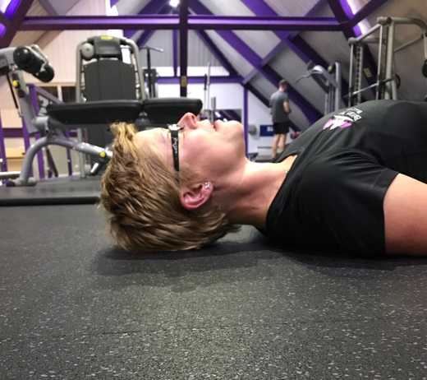
Lie on a firm surface with the spine in a neutral position, resting the back of the head on the floor.

If you need to tip your head back to do this as you have a pronounced rounding of the upper back, then you may find it more comfortable to do this standing against a wall.

Alternatively, use a firm support under the head that will give you a neutral neck position.

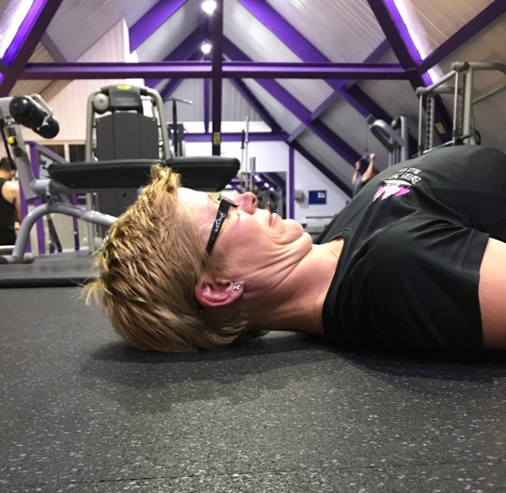
Bring your chin to your chest, use two fingers on the chin to encourage this movement if needed.

Keep your shoulders back, not allowing them to round forward. Maintain contact between the back of the head and the floor.

In the photos, you will see the gap between the floor and my neck is reduced as a result of the stretch. Feel the stretch in the back of the neck and hold for 5 to 10 seconds to start with. Release and repeat.

Whilst postural problems are common and increasingly so due to desk bound working, long term bad habits, injury amongst many causes. However, improvements are possible through a small but consistent attention to the affected area.

It’s worth getting even the smallest sources of tension or mobility issues resolved sooner rather than later, to help ease pain, improve your posture while exercising or to keep healthy for life, so get in touch with how you can stand tall and feel amazing!

